

**Fundamental of programming Assignment 1**

**Name: Muhammad Amad Naeem**

**Section: ME-15 B**

**CMS ID: 467469**

**Task 1:**

**#include<iostream>**

**using namespace std;**

**int main(){**

**int x;**

**cout<<"Enter an integer: ";**

**cin>>x;**

**cout<<"Factors of "<<x<<": "<<endl;**

**for(int i=1;i<=x;i++){**

**if(x%i==0){**

**cout<<i<<endl;**

**}**

**else{**

**continue;**

**}**

**}**

**return 0;**

**}**

**Output:**

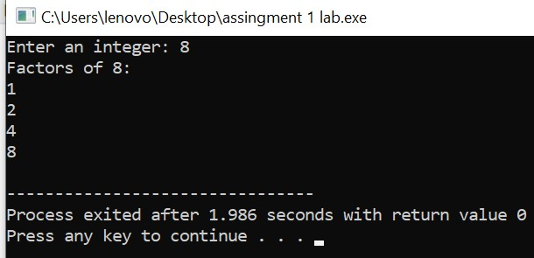

**Task 2:**

**#include <iostream>**

**int main() {**

**int x = 5;**

**int y = 10;**

**if (x == 5)**

**if (y == 10)**

**std::cout << "x is 5 and y is 10" << std::endl;**

**else**

**std::cout << "x is not 5" << std::endl;**

**return 0;**

**}**

**Output:**

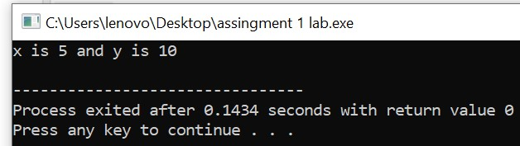

**Task 3:**

**#include<iostream>**

**using namespace std;**

**int main(){**

**int x;**

**cout<<"Enter an integer: ";**

**cin>>x;**

**if(x>10 && x<=20){**

**cout<<1;**

**}**

**else{**

**cout<<0;**

**}**

**return 0;}**

**Output:**

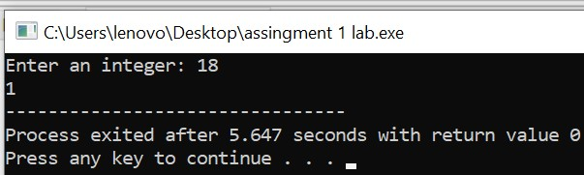

**Task 4:**

**#include<iostream>**

**using namespace std;**

**int main(){**

**int num=0,i, j=1,factors=0;**

**cout<<"Enter a number: ";**

**cin>>num;**

**i=num;**

**if(num<=1){**

**cout<<"Enter a number greater than or equal to 2";**

**}**

**else{**

**while(num>=2){**

**factors=0;**

**j=1;**

**while(j<=i){**

**if(num%j==0){**

**factors++;**

**}**

**j++;**

**}**

**if(factors==2){**

**break;**

**}**

**num--;**

**}**

**cout<<"the largest prime number less than or equal to "<<i<<": "<<num;**

**}**

**return 0;**

**}**

**Output:**

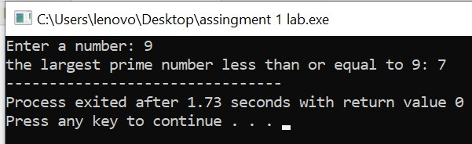

**Task 5:**

**#include<iostream>**

**using namespace std;**

**int main(){**

**string str1, str2, change;**

**change = "";**

**cout<<"Enter String1: ";**

**cin>>str1;**

**cout<<"Enter String2: ";**

**cin>>str2;**

**if (str1 == str2) {**

**for (int i = 0; i < str1.length(); i++) {**

**change = str1[i] + change;**

**}**

**cout<<"Strings are equal.The changed string is: ";**

**cout<<change;**

**}**

**else {**

**cout<<"Strings are not equal";**

**}**

**return 0;}**

**Output:**

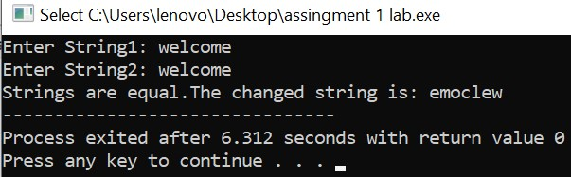

**Task 6:**

**#include<iostream>**

**using namespace std;**

**int main(){**

**int divisor, quotient;**

**int remainder, dividend;**

**cout<<"Enter a divisor: ";**

**cin>>divisor;**

**cout<<"Enter a dividend(must be greater than divisor): ";**

**cin>>dividend;**

**if (dividend < divisor) {**

**cout<<"dividend shall be greater than divisor.";**

**return 1;**

**}**

**remainder = dividend;**

**for (int i = 1; i <= dividend; i++) {**

**remainder -= divisor;**

**if (remainder < divisor) {**

**quotient = i;**

**break;**

**}**

**}**

**cout<<"Answer = "<<quotient;**

**return 0;}**

**Output:**

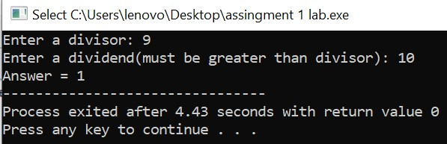

**Task 7:**

**#include<iostream>**

**using namespace std;**

**int main(){**

**string str, result;**

**bool found;**

**result = "";**

**cout<<"Enter the String: ";**

**cin>>str;**

**for (int i = 0; i < str.length(); i++) {**

**found = false;**

**for (int j = 0; j < result.length(); j++) {**

**if ( str[i] == result[j] ) {**

**found = true;**

**}**

**}**

**if (found == false) {**

**result += str[i];**

**}**

**}**

**cout<<"resultant string= "<<result;**

**return 0;**

**}**

**Output:**

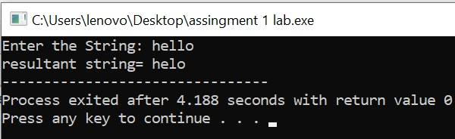

**Task 8:**

**#include<iostream>**

**using namespace std;**

**int main(){**

**int arr1[8], arr2[5] = {1,2,3,4,5};**

**cout<<"the array is: {";**

**for (int i = 0; i<5; i++) {**

**cout<<arr2[i];**

**if (i==4)**

**continue;**

**cout<<", ";**

**}**

**cout<<"}"<<endl;**

**for (int i = 0; i<5; i++) {**

**arr1[i] = arr2[i];**

**}**

**cout<<"Enter the 3 integers that you want to add to the array: "<<endl;**

**for (int i = 5; i<8; i++)**

**cin>>arr1[i];**

**cout<<"the new elements of the array are:"<<endl;**

**for (int i = 0; i<8; i++) {**

**cout<<arr1[i]<<" ";**

**}**

**return 0;}**

**Output:**

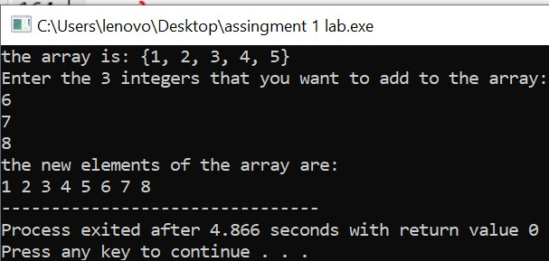

**Task 9:**

**#include<iostream>**

**using namespace std;**

**int main(){**

**int a, b, c;**

**int sum,n, arr[10];**

**cout<<"Enter 10 integers:"<<endl;**

**for (int i = 0; i<10; i++) {**

**cin>>arr[i];**

**}**

**bool found = false;**

**cout<<"Enter integer n: ";**

**cin>>n;**

**cout<<"the Triplets are: ";**

**for (int i = 0; i<10; i++) {**

**for (int j = 0; j<10; j++) {**

**if (i == j){**

**continue;}**

**for (int k = 0; k<10; k++) {**

**if (k == i || k == j)**

**{continue;**

**}**

**sum = arr[i] + arr[j] + arr[k];**

**if (sum == n) {**

**cout<<" ("<<arr[i]<<", "<<arr[j]<<", "<<arr[k]<<")";**

**found = true;**

**}**

**}**

**}**

**}**

**if (found == false) {**

**cout<<"No Triplet";**

**}**

**return 0;}**

**Output:**

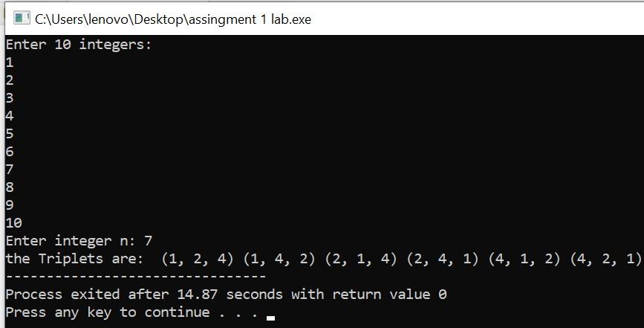

**Task 10:**

**#include<iostream>**

**using namespace std;**

**int main(){**

**int temp, a = 6, arr1[a];**

**cout<<"Enter "<<a<<" integers: "<<endl;**

**for (int i = 0; i<a; i++) {**

**cin>>arr1[i];**

**}**

**for (int j = 0; j<(a-1); j++) {**

**for (int i = 0; i<(a-1); i++) {**

**if (arr1[i]>arr1[i+1]) {**

**temp = arr1[i];**

**arr1[i] = arr1[i+1];**

**arr1[i+1] = temp;**

**}**

**}**

**}**

**cout<<"Array= {";**

**for (int i = 0; i<a; i++) {**

**cout<<arr1[i];**

**if (i == a-1){**

**continue;**

**}**

**cout<<",";**

**}**

**cout<<"}";**

**return 0;**

**}**

**Output:**

